Huawei OceanStor Pacific Series — The Trusted Choice for HPDA
[June 2021, Shenzhen] Enterprise Strategy Group (ESG), an authoritative validation organization, recently released a technical review of the Huawei OceanStor Pacific storage series. Based on the actual operating environment, the rigorous review confirms that Huawei OceanStor Pacific delivers consistently high performance and flexible access to ultra-large data sets in High-Performance Data Analytics (HPDA) scenarios. It efficiently serves data-intensive HPDA applications and its high-density design reduces TCO by up to 61%.
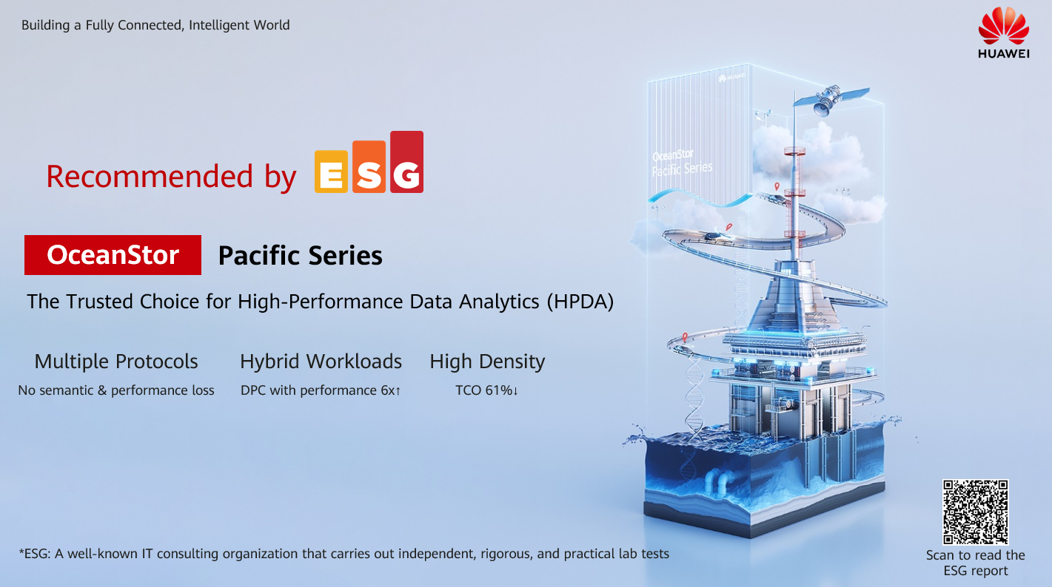

As high-performance computing (HPC) is increasingly integrated with new technologies such as big data and AI, it’s accepted in the industry that a move from HPC to HPDA is inevitable. However, the explosion of HPDA applications poses new challenges to storage in terms of complex hybrid workloads and analytical efficiency. In the IT field, HPDA places the most demanding requirements on storage scalability, performance, and stability.

Multi-Protocol Support
ESG analyzed OceanStor Pacific in a multi-protocol test environment to validate semantic integrity, performance, and advanced functionality like snapshots, quotas, QoS, and object versioning. The multi-protocol capability of OceanStor Pacific allows one copy of data to be shared using multiple protocols. OceanStor Pacific supports NFS, CIFS, HDFS, and S3 protocols. This is designed to improve analytical efficiency because data written using one protocol can be read over multiple protocols without data migration, while preserving protocol semantics and providing consistent performance.

Hybrid Workload
Increasingly complicated workloads in HPDA scenarios present a serious challenge to storage systems. ESG tested the performance of the Huawei OceanStor Pacific parallel file system with the Huawei Distributed Parallel Client (DPC). Unlike traditional NFS clients, DPC enables a single client to concurrently access multiple storage nodes, eliminating single-client and single-stream performance bottlenecks. DPC supports MPI-IO and RDMA networks to better adapt to application ecosystems and reduce response time. The OceanStor Pacific file system uses features like metadata distribution, targeted processing of large and small I/Os, and disk indexing to satisfy both high bandwidth and high IOPS requirements.

High-Density Design and TCO
ESG modeled and compared the storage-related costs that could be expected when deploying a scale-out NAS system and a Huawei OceanStor Pacific 9550 high-density system. Huawei OceanStor Pacific demonstrates a 61% overall TCO advantage over five years. It also offers impressive density, scaling to 1.68 PB in just 5 U. The largest savings (64%) come from hosting costs, thanks to the extremely high-density platform. CapEx savings are 62%, while power and cooling show a 32% advantage in this comparison.

ESG concluded that Huawei OceanStor Pacific is a next-generation storage system designed for HPDA that provides consistent performance, multi-protocol support, hybrid workload access, extremely high-density design, and lower TCO. OceanStor Pacific is the trusted choice for a wide range of data-intensive HPC applications.

To read the ESG technical review, please visit https://interactive.esg-global.com/reports/Huawei-OceanStor-Pacific-Next-gen-HPDA-Storage
About ESG
ESG, a division of TechTarget, is an IT analyst, research, validation, and strategy firm that provides market intelligence and actionable insight to the global IT community.

